33920-50G11
(112043-0232 EPROM)

(Some of) what I know

Updated 3th March 2022

Introduction

The 50G11 is based on the 68HC11G5 micro-controller which is an 84-pin automotive version.
The ECU has its code and tables, located in a 27C256 EPROM.
There are a number of custom ICs in the design which are typical of Denso ECUs of this period.
This ECU is from a 1 litre 3-cyl engine with 5 speed manual transmission although it appears that the code supports an auto trans.
Ignition Timing

Cranking
Cranking Advance is 5 degrees

Running
There are ten parameters that are summed to calculate the total ignition advance

Ign_Param1
Base advance
Ign_Param2
WTS advance or retard
Ign_Param3
IAT retard (high load)
Ign_Param4
IGP4 = IGP1+IGP2-IGP3
Ign_Param5
Idle advance for deltaRPM?
Ign_Param6
Constant value advance at idle? Post idle correction?
Ign_Param7
Idle advance for PS and EL?
Ign_Param8
Idle advance v WTS????
Ign_Param9
Advance correction for VSS??
Ign_Param10

IGN_ADV1 = IGP4+IGP5+IGP6+IGP7-IGP8-IGP9-IGP10

IGN_ADV = (IGN_ADV1 + 5) or degrees

Ignition advance is calculated as a 16-bit signed integer.
Ignition advance is limited between +53 (53 degrees BTDC) and -10 (10 degrees ATDC).
Ignition Dwell period is calculated from a 3D look up table at C775h from RPM v Batt Volts

IGP1 - Base Advance
Base advance uses one of four tables:
Spark Advance v RPM (idle) – 1x8. RPM
Spark Advance Base (EGR off) – 15x8 RPM v MAP
Spark Advance Base (below 4400RPM and EGR on) – 15x8 RPM v MAP
Spark Advance Base (Auto?) – 15x8 RPM v MAP

IGP2 - WTS Correction
Spark Advance v WTS (Low Load)
below 800mBar and below 60C – 1 x 5 WTS
Spark Retard v WTS (High Load)
above 800mBar and above 89C – 1 x 3 WTS

IGP3 - IAT Correction
Spark Retard v IAT (High Load)
above 1305mBar (disabled!) – 1 x 4 IAT

IGP5 – RPM Correction at idle ?
- 1 x 4

IGP6 –

Injector Pulse Width

There are two paths for inj_pw calculation:

INJ_CALCS_0 -> hit when running
Calls -> Do_INJ_Calcs_0_0_0 stores to byte_A8

INJ_CALCS_0_0 -> hit even when not running

Injector Pulse Width is calculated as:
INJPWH = INJ_PW + INJ_DWELL

INJ_PW =

Fast table look up and interpolation
2D table lookups

Tables are generally stored as a structure:
0 – min value
1 – max value
2 – scalar
3 – table start address
N – table end address

The interpolation algorithm uses simple scaling and fractional multiplication.
The minimum value is subtracted from the input value then the algorithm uses a multiplier to shift the data to a 16-bit value where the upper byte is the index value so a multiplier of 16 right shifts the data 4-bits which is equivalent to an upper byte with a divisor of 16.

15 | 14 | 13 | 12 | 11 | 10 | 9 | 8 | 7 | 6 | 5 | 4 | 3 | 2 | 1 | 0
- | - | - | - | - | - | - | - | 1 | 1 | 1 | 1 | 1 | 1 | 1 | 1
0 | 0 | 0 | 0 | 1 | 1 | 1 | 1 | 1 | 1 | 1 | 1 | 0 | 0 | 0 | 0

Multiplier 16 8 4
Divisor 16 32 64

Example - Injector dwell period

Table:

INJ_DWELL_LUT: fcb $43 ; min
fcb $80 ; max
fcb $10 ; multiplier
INJ_DWELL_LUT_1: fcb $BB, $BB, $66, $47, $35, $2A, $22, $1C, $17

For this table the maximum input voltage is 15.23V = C3 which is a 7-bit number so:
- Modified input = Input value – 67
- If modified input value >128, set to 128
- Modified input value * 16 (max = 7-bits*16 = 7F0h)
- Index = high byte
- Mantissa = low byte

So the table index can be derived as:
Cell | 0 | 1 | 2 | 3 | 4 | 5 | 6 | 7 | 8
Input Value | 67 | 83 | 99 | 115 | 131 | 147 | 163 | 179 | 195
BattV (h) | 0x43 | 0x53 | 0x63 | 0x73 | 0x83 | 0x93 | 0xA3 | 0xB3 | 0xC3
BattV (V) | 5.234 | 6.484 | 7.734 | 8.984 | 10.234 | 11.484 | 12.734 | 13.984 | 15.234
returns | BB | BB | 66 | 47 | 35 | 2A | 22 | 1C | 17

Main Code (part 1):
INJ_DWELL_CALC:
ldaa BATT_RAW ; 8-bit ADC result
ldx #$C12B
jsr TABLE_LU_2D ; table look up with max and min

Interp code (part 1):

TABLE_LU_2D: suba 0,x ; A – min value
bcc testMax ; A is greater then OK
clra ; else A = 0
testMax: cmpa 1,x ; A – max. value
bls loc_F430 ; less than value then OK
ldaa 1,x ; otherwise load max.
scaleValue: ldab 2,x ; A * multiplier
mul

The 11-bit value is treated as an unsigned fractional value where the high byte is a 3-bit integer value from 0 to 7 and the low byte is a 5-bit fractional value from 0 to 0.96875 (this is an 8-bit virtual right shift).
Some look ups will skip this part of the code i.e. if the input value is more than 8-bits or scaling is done in the main part of the code.

Interp code (part 2):

TABLE_LU_2Da:
psha ; save the integer/index value to the stack
tba ; copy the mantissa to A
pulb ; copy the index/integer value to B
abx ; add B to table address
tab ; copy the mantissa to A
beq loc_F444 ; if the mantissa is zero skip the interpolation
ldab 4,x ; get X2
subb 3,x ; subtract X1
bcc doPos ; bra if +ve
negb ; otherwise do a 2's comp
nega
inx ; and increment x

doPos: mul ; D = mantissa * (X2- X1)

loc_F444: adda 3,x ; and add to the initial value
rts

The value from the first cell is added to the value in A (it is not added to D!)

Main Code (part 2):
lsrd
lsrd
lsrd
lsrd
lsrd
std INJ_DWELL
rts

The 16-bit result from the interpolation algorithm is then right shifted 5 bits and stored as the 11-bit dwell period.

Example 2:

WTS Linearisation

F7CA: fcb 7
fcb 0
fcb 0
F7CD: WTS_LIN_LUT: fcb $FF

This is a 32-cell table and the code calls TABLE_LU_2Da which skips the max, min and multiplier section of the code so none of the above are implemented.
The table starts at F7CD, but the pointer is to F7CA which is actually part of the previous table, this is necessary because the interpolation fetches the index values from 3,x and 4,x

Main code:

CB83 ldx #$F7CA
ldd WTS_RAW ; HC11G5 ADC is 10-bit left justified
lsrd
lsrd
lsrd
jsr TABLE_LU_2Da ; get WTS_LIN

The scaling is performed in the main code before the interpolation routine is called.

3D table lookups

3D tables are mostly limited within the main code

Analogue inputs

The ADC is auto scanning 8-channels? Continuously. ADC values are read in a real time interrupt (RTII).
RTI interrupt rate is set in the PACTL register:
PACTL is initialised as 0x0E = Eclk/2¹¹
I@ XTAL = 1.02ms, RTI rate = 1.02ms

The datasheet states that each set of four conversions takes 144 E clock cycles, so maybe 36 cycles per conversion, there is no specific data.
Assuming 36 cycles per conversion the 8 channels = 288 E clock cycles
E clock = XTAL/4 = 2MHz
288 E clock cycles = 144us

So the maximum lag is <144us

Main scheduler

The main scheduler runs on a 4.096ms tick (ML_Tick_4_1ms) derived from the 1.024ms RTI, the RTI frequency is set in PACTL the settings for which are specific to the G processors.

Where the scheduler calls exceed ? ms the do_CPS_Event is called.
On each call he scheduler shifts the counter to the right and tests the carry so no more than one tick is executed on any one call of the scheduler.

ML_Tick_8_2ms:

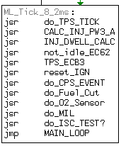

ML_Tick_16_8ms

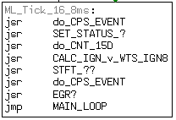

ML_Tick_32_7ms

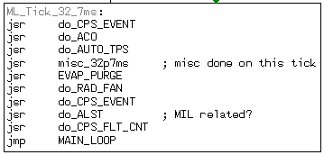

ML_Tick_65_5ms

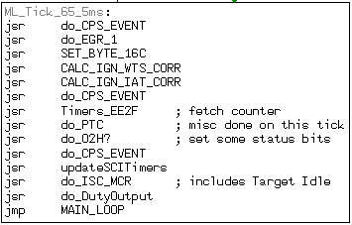

ML_Tick_131ms

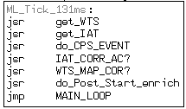

ML_Tick_262ms

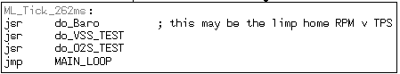

ML_Tick_524ms

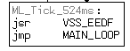

ML_Tick_1048ms

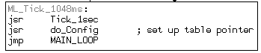

The 1 second tick includes the VSS calculation, a CTS/Baro function and a 5sec TFS counter for an O2 function.

Timing loops

Counter_3C
Loc_F8B1 (convert to func?)
several /2 and conditional jumps – never loaded (/256?)
F8B1 is re-entered from each branch? – maybe main loop, jmp to here after init
Counter 3c is every n main loops

F7EE? – at start of F8B1 routine
Then EC51

Possible timers/counters:
Byte_ED
Byte_15D
Byte_15F

portJ, bit1 = wdog reset

IC2I is VSS – check timing is =km/h (not PAI)?
Where is CAS? Pin 9 = IC3? 6 = OC5/IC4,
3=OC2 =>T809 -> inj
OC5/IC4 = OC?

IC3/PA0 => start
IC3 = TFLG1, bit0
EFB5 tests TFLG1,0 => from F7EE -clears status27, 4, maybe IFS?

MAP fault code

The ECU will set a fault if the MAP signal is at a rail, it will also set a fault if the MAP signal is not credible.

MAP fault set @
F5CF
F5E3
F654

MAP error check:
MAP bra at CB74

